**DAILY ONLINE ACTIVITIES SUMMARY**

|  |  |  |  |  |  |  |  |
| --- | --- | --- | --- | --- | --- | --- | --- |
| **Date:** | **29/05/2020** | | | | **Name:** | **Sheetal** | |
| **Sem & Sec** | **8 B** | | | | **USN:** | **4AL16CS091** | |
| **Online Test Summary** | | | | | | | |
| **Subject** | | **BDA** | | | | | |
| **Max. Marks** | | **30** | | **Score** | | **21** | |
| **Certification Course Summary(Internship)** | | | | | | | |
| **Task** | **Study-Learning data analytics concepts with platform specified**  **POC- working on development of custom visual for the dashboard using typescript language with nodejs D3.js** | | | | | | |
| **company** | | | **Gain-insights** | **Duration** | | | **8 hr** |
| **Coding Challenges** | | | | | | | |
| **Problem Statement:1):Given an array arr[] of size N and an integer K. The**  **Task is to find the last remaining element in the array after reducing**  **The array.**  **.** | | | | | | | |
| **Status:completed** | | | | | | | |
| **Uploaded the report in Github** | | | | **Yes** | | | |
| **If yes Repository name** | | | | [alvas-education-foundation](https://github.com/alvas-education-foundation)/ **[sheetal-shettigar](https://github.com/alvas-education-foundation/sheetal-shettigar)** | | | |
| **Uploaded the report in slack** | | | | **Yes** | | | |

ONLINE TEST:

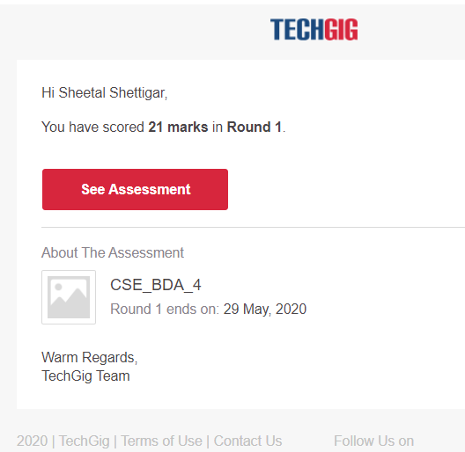

CODING CHALLENGE:

PROGRAM 1 :

Void moreThanNdK(int arr[],int n,int k)

{

if(k<2)

return;

Struct eleCount temp[k-1];

for(int i=0;i<k-1;i++)

temp[i].c=0;

for(int i=0;i<n;i++)

{

Int j;

for(j=0;j<k-1;j++)

{

if(temp[j].e==arr[i])

{

temp[j].c+=1;

break;

}

}

if(j==k-1)

{

int l;

for(l=0;l<k-1;l++)

{

if(temp[l].c==0)

{temp[l].e=arr[i];

temp[l].c=1;

break;

}

}

if(l==k-1)

for(l=0;l<k;l++)

temp[l].c-=1;

}

}

for(int i=0;i<k-1;i++)

{

int ac=0;

for(int j=0;j<n;j++)

if(arr[j]==temp[i].e)

ac++;

if(ac>n/k)

cout<<"Number:"<<temp[i].e

<<"Count:"<<ac<<endl;

}

}